EX No:1b | EDA DATA CLEANING

AIM
To perform exploratory data analysis on the Chess Games Dataset by examining the dataset structure, dimensions, data types, statistical characteristics, missing values, rated and unrated game distributions, victory-status and winner distributions, player rating patterns, game-length analysis based on the number of turns, opening-wise game patterns, opening-move analysis, player rating comparisons, and correlation analysis, followed by cleaning and exporting the dataset for further analysis.
ALGORITHM
- Import the required Python libraries such as Pandas, NumPy, and Matplotlib.
- Load the Chess Games Dataset (games.csv) into a Pandas DataFrame.
- Display the first five and last five records of the dataset to understand the structure and contents of the chess-game records.
- Display the dataset information, including its shape, column names, data types, and number of records.
- Generate descriptive statistical information for numerical attributes such as turns, white_rating, black_rating, and opening_ply.
- Identify the number of missing values present in each column of the dataset.
- Remove blank rows and duplicate game records from the dataset.
- Perform data cleaning and standardization on the required categorical and numerical attributes, including rated, victory_status, winner, increment_code, opening_eco, and opening_name.
- Create a Rating Difference attribute by calculating the absolute difference between the White player's rating and Black player's rating, and use it to analyze rating differences between players.
- Analyze the distribution of chess games across different victory_status categories and determine the outcome patterns of the games.
- Analyze the distribution of games across different winner categories, including White, Black, and Draw.
- Analyze the relationship between the number of turns and player ratings, and identify variations in game duration across different game outcomes.
- Calculate and analyze the Win Percentage for White, Black, and Draw based on the total number of game records.
- Calculate and analyze the correlation between numerical attributes such as turns, white_rating, black_rating, opening_ply, and the derived Rating Difference attribute.
- Export the cleaned Chess Games Dataset into CSV, Excel, and JSON formats and display a confirmation message after successful file creation.
CODE
import os
import pandas as pd
import numpy as np
import matplotlib.pyplot as plt

path = "games.csv"

print("Dataset path:", path)

df = pd.read_csv(path)

# Display First Five and Last Five Records

print("\nFirst 5 rows:")
display(df.head())

print("\nLast 5 rows:")
display(df.tail())

# Display Dataset Information

print("\nDataset information:")
df.info()

print("\nShape:")
print(df.shape)

print("\nColumns:")
print(df.columns.tolist())

print("\nData types:")
print(df.dtypes)

# Statistical Description

print("\nStatistical description:")
display(df.describe())

# Missing Values

print("\nMissing values:")
display(df.isnull().sum())

# Remove Blank Rows and Duplicate Records

df = df.dropna(how="all")
df = df.drop_duplicates()

print("\nDataset after removing blank rows and duplicates:")
print(df.shape)

# Standardize Categorical Columns

df["rated"] = (
df["rated"]
.astype(str)
.str.strip()
.str.title()
)

df["victory_status"] = (
df["victory_status"]
.astype(str)
.str.strip()
.str.lower()
)

df["winner"] = (
df["winner"]
.astype(str)
.str.strip()
.str.title()
)

df["opening_eco"] = (
df["opening_eco"]
.astype(str)
.str.strip()
.str.upper()
)

df["opening_name"] = (
df["opening_name"]
.astype(str)
.str.strip()
)

print("\nCategorical values after standardization:")

print("\nRated:")
print(df["rated"].unique())

print("\nVictory Status:")
print(df["victory_status"].unique())

print("\nWinner:")
print(df["winner"].unique())

# Create Rating Difference

df["Rating_Difference"] = abs(
df["white_rating"] - df["black_rating"]
)

print("\nRating Difference:")
display(
df[
["white_rating", "black_rating", "Rating_Difference"]
].head()
)

# Victory Status-wise Analysis

print("\nVictory Status-wise Game Count:")

display(
df.groupby("victory_status")
.size()
.sort_values(ascending=False)
)

# Winner-wise Game Analysis

print("\nWinner-wise Game Count:")

display(
df.groupby("winner")
.size()
.sort_values(ascending=False)
)

# Rated vs Unrated Game Analysis

print("\nRated vs Unrated Games:")

display(
df.groupby("rated")
.size()
.sort_values(ascending=False)
)

# Game Length Analysis

print("\nAverage Number of Turns by Winner:")

display(
df.groupby("winner")["turns"]
.mean()
.sort_values(ascending=False)
)

# Opening-wise Game Analysis

print("\nTop 10 Opening Names:")

display(
df.groupby("opening_name")
.size()
.sort_values(ascending=False)
.head(10)
)

# Average Ratings Analysis

print("\nAverage White and Black Ratings:")

print("Average White Rating:",
round(df["white_rating"].mean(), 2))

print("Average Black Rating:",
round(df["black_rating"].mean(), 2))

# Win Percentage

total_games = len(df)

white_wins = (df["winner"] == "White").sum()
black_wins = (df["winner"] == "Black").sum()
draws = (df["winner"] == "Draw").sum()

white_percentage = (white_wins / total_games) * 100
black_percentage = (black_wins / total_games) * 100
draw_percentage = (draws / total_games) * 100

print("\nWin Percentage:")

print("White Win Percentage:",
round(white_percentage, 2), "%")

print("Black Win Percentage:",
round(black_percentage, 2), "%")

print("Draw Percentage:",
round(draw_percentage, 2), "%")

# Correlation Analysis

print("\nCorrelation:")

display(
df[
[
"turns",
"white_rating",
"black_rating",
"opening_ply",
"Rating_Difference"
]
].corr()
)

# Export Cleaned Dataset

df.to_csv(
"Games_Cleaned.csv",
index=False
)

df.to_excel(
"Games_Cleaned.xlsx",
index=False
)

df.to_json(
"Games_Cleaned.json",
orient="records",
indent=4
)

print("\nCSV, Excel and JSON files created successfully.")

OUTPUT
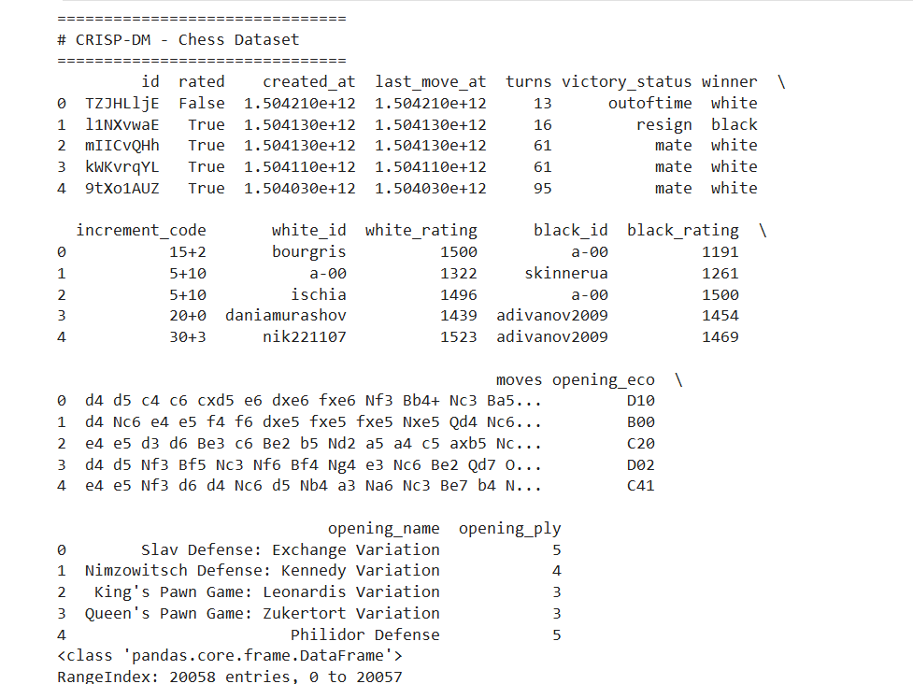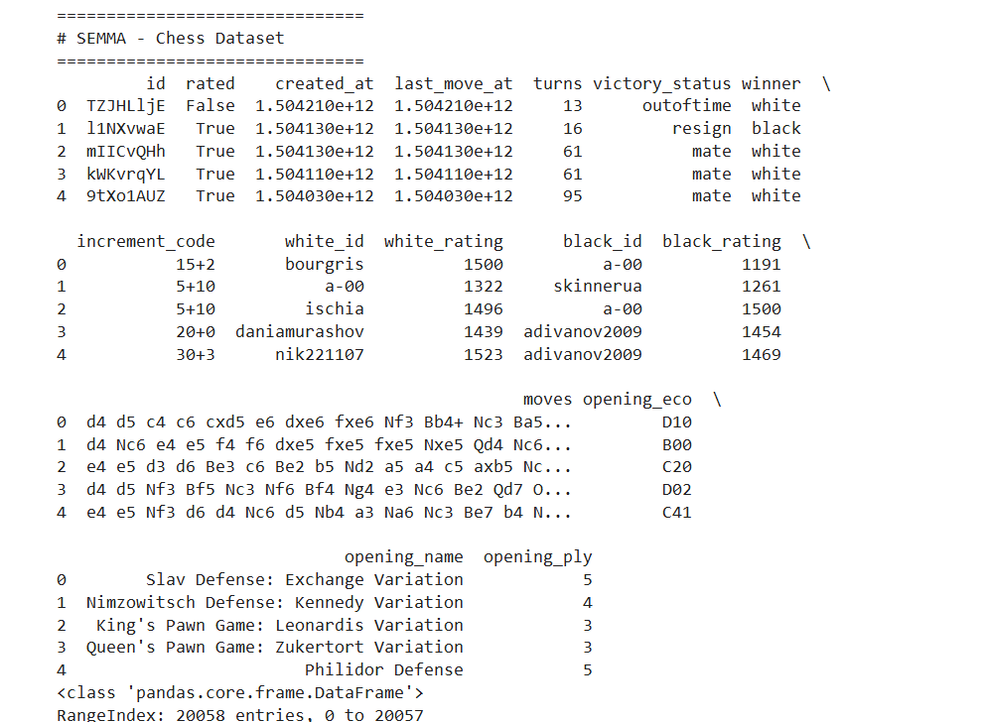
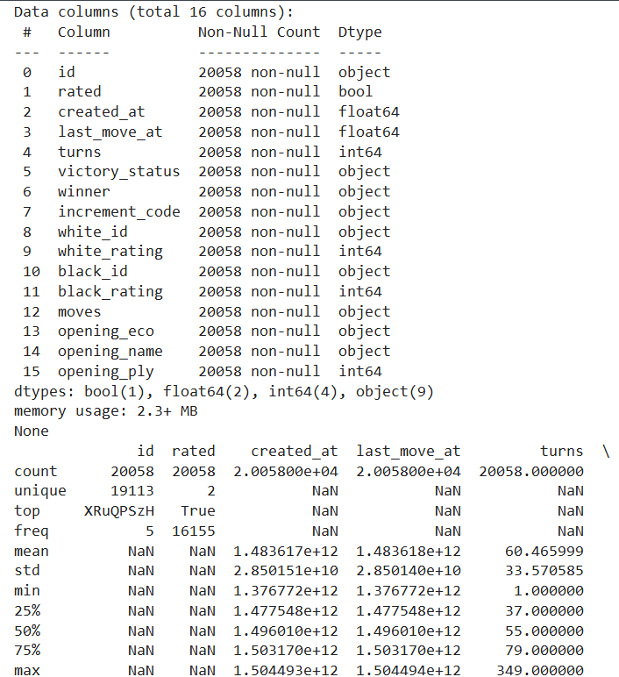

RESULT

